Link: <http://www.studytonight.com/computer-networks/unbounded-transmission-media>

Under: Unguided/Unbounded media **replace** the existing text with below:

Unguided medium transport electromagnetic waves without using a physical conductor. This type of communication is often referred to as wireless communication. Signals are normally broadcast through free space and thus are available to anyone who has a device capable of receiving them.

The below figure shows the part of the electromagnetic spectrum, ranging from 3 kHz to 900 THz, used for wireless communication.

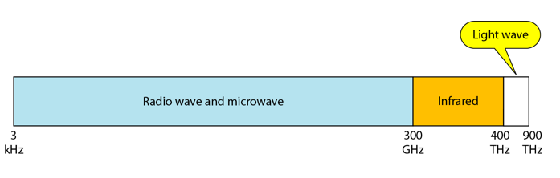

Unguided signals can travel from the source to the destination in several ways: ground propagation, sky propagation and line-of-sight propagation as shown in below figure.

Figure: Propagation modes

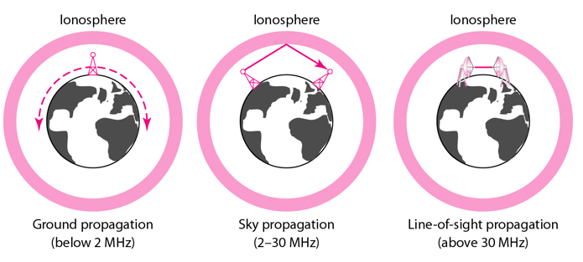

* Ground Propagation: In this, radio waves travel through the lowest portion of the atmosphere, hugging the Earth. These low-frequency signals emanate in all directions from the transmitting antenna and follow the curvature of the planet.
* Sky Propagation: In this, higher-frequency radio waves radiate upward into the ionosphere where they are reflected back to Earth. This type of transmission allows for greater distances with lower output power.
* Line-of-sight Propagation: in this type, very high-frequency signals are transmitted in straight lines directly from antenna to antenna.

We can divide wireless transmission into three broad groups:

* Radio waves
* Micro waves
* Infrared waves